Financial Reporting Center
How to Respond to a Comfort Letter/Third-Party Verification Request
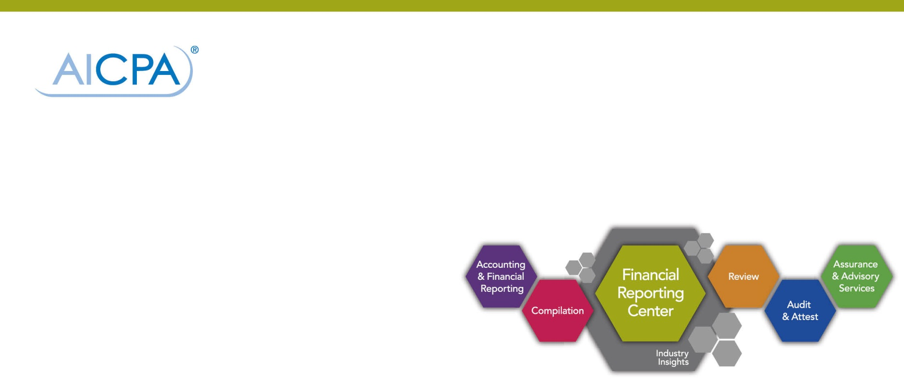
“CPAs are often faced with requests for information from lenders and are not sure how to respond, but offering the right response can present a real service opportunity for your practice,” said Chuck Landes, CPA, Vice President, Professional Standards and Services with the American Institute of CPAs (AICPA). “While you cannot provide assurance on matters relating to solvency, you can provide a number of services to your clients with other types of responses or activities that address their particular situation.”
Understanding Types of Requests
You may be asked to provide any number of verifications. Some frequent requests include verification of:
- Self-employment status
- Income
- Number of employees
- Business ownership
- Business profitability
- Business sustainability
- Real estate purchase impact on business
- Business loan impact
There are several ways a CPA can respond and not every response need be in the form of an attestation engagement.
Determining the Proper Response
A CPA may provide a response that states factual information and may provide a conclusion, assuming the CPA has performed sufficient procedures and has a basis for the response. A CPA may respond verbally or via email, form letter or other written channels. Additionally, an accountant may provide a client with these other options:
- Prepare an audit, review or compilation of financial statements;
- Offer an examination, review or compilation of pro forma financial information;
- Supply an examination or compilation of prospective financial information; or
- Write an agreed-upon procedures report, as long as the agreed-upon procedures do not provide any assurance on matters related to solvency.
For example, some CPAs are receiving requests from bank lenders on verification of financial information from a tax return. Without providing assurance on matters relating to solvency, CPAs can respond to such requests in a number of ways, such as:
- By providing a letter explaining that the CPA prepared the tax return—based on information provided by the client—and that such financial information agrees with the tax return prepared by the CPA.
- By performing an attest engagement for the client based on the level of assurance needed by the lender.
Another example may involve a request for self-employment verification, in which case, the CPA may respond by performing an engagement to gather and provide the requested information for the client or, if more assurance is needed, an examination or review engagement.
The Question of Solvency
According to AT Section 9101, paragraph .27 of Interpretation No. 2, CPAs cannot provide assurance on matters relating to solvency. Matters relating to solvency are subject to legal interpretation under the Federal Bankruptcy Code and various state fraudulent conveyance and transfer statutes. Because these matters are not clearly defined in an accounting sense and are subject to varying interpretations, practitioners don’t have suitable criteria to evaluate a subject matter or make an assertion. Lenders are often concerned with legal issues on matters relating to solvency; however, CPAs are generally unable to evaluate or provide assurance on these matters of legal interpretation. The attestation standards preclude practitioners from giving any form of assurance on matters relating to solvency.
Here are a few examples of the types of solvency requests a practitioner is precluded from providing any form of assurance on, whether through examination, review, agreed-upon procedures engagements or any other consultative engagements.
Assurance that the client (business):
- is not insolvent at the time the debt is incurred or would not be rendered insolvent in the near future
- does not have unreasonably small capital
- has the ability to pay its debts as they mature
Or that the client’s (business’s):
- fair salable value of assets exceeds liabilities
- contingent liabilities will not pose a problem
- commitments will not have an impact on its business operations
Remember, providing third-party verification letters is an individual, or firm, decision. Credit decisions should be based on the requestor’s exercise of due diligence in obtaining and considering multiple factors and information and not solely granted based on your response. Make sure you obtain the client’s consent before revealing confidential client information.
Obtaining Client Consent
A CPA cannot provide any confidential client information without signed, written consent from the client. Obtaining client consent to share tax return information creates an added complication: using a standard client consent form is not sufficient. In fact, it’s a crime. Internal Revenue Code Section 7216 dictates that CPAs use a specific format to obtain consent to disclose client tax return information to a third party, so be sure you follow the Code when being asked to provide copies of tax information, tax returns or other information used in the preparation of a client’s tax return.
Resources for Your Use
Providing third-party verifications is a critical service CPAs provide to their clients, and understanding the ins-and-outs can help you make quick decisions and foster client relationships.
To find out more, visit the AICPA’s Financial Reporting Center webpage dedicated to third-party verification requests, aicpa.org/verifications, where you can find information that will help you make smart decisions about whether providing a comfort letter makes sense for you and your firm. You’ll find guidance from various AICPA resources, including sample response letters from the AICPA’s Private Company Practice Section (PCPS), a toolkit for your use and an article by AON, the AICPA’s professional liability insurance program. Additionally, on the third-party verifications page, you’ll find this video featuring Sue Coffey, CPA, CGMA, AICPA Senior Vice President – Public Practice and Global Alliances, discussing third party verification requests and the legal issues related to solvency requests.
DISCLAIMER: This publication has not been approved, disapproved or otherwise acted upon by any senior committees of, and does not represent an official position of, the American Institute of Certified Public Accountants. It is distributed with the understanding that the contributing authors and editors, and the publisher, are not rendering legal, accounting, or other professional services in this publication. If legal advice or other expert assistance is required, the services of a competent professional should be sought.
Copyright © 2014 by American Institute of Certified Public Accountants, Inc. New York, NY 10036-8775. All rights reserved. For information about the procedure for requesting permission to make copies of any part of this work, please email copyright@aicpa.org with your request. Otherwise, requests should be written and mailed to the Permissions Department, AICPA, 220 Leigh Farm Road, Durham, NC 27707-8110.

