Financial Reporting Center
Need Third-Party Verification? Ask a CPA for Guidance
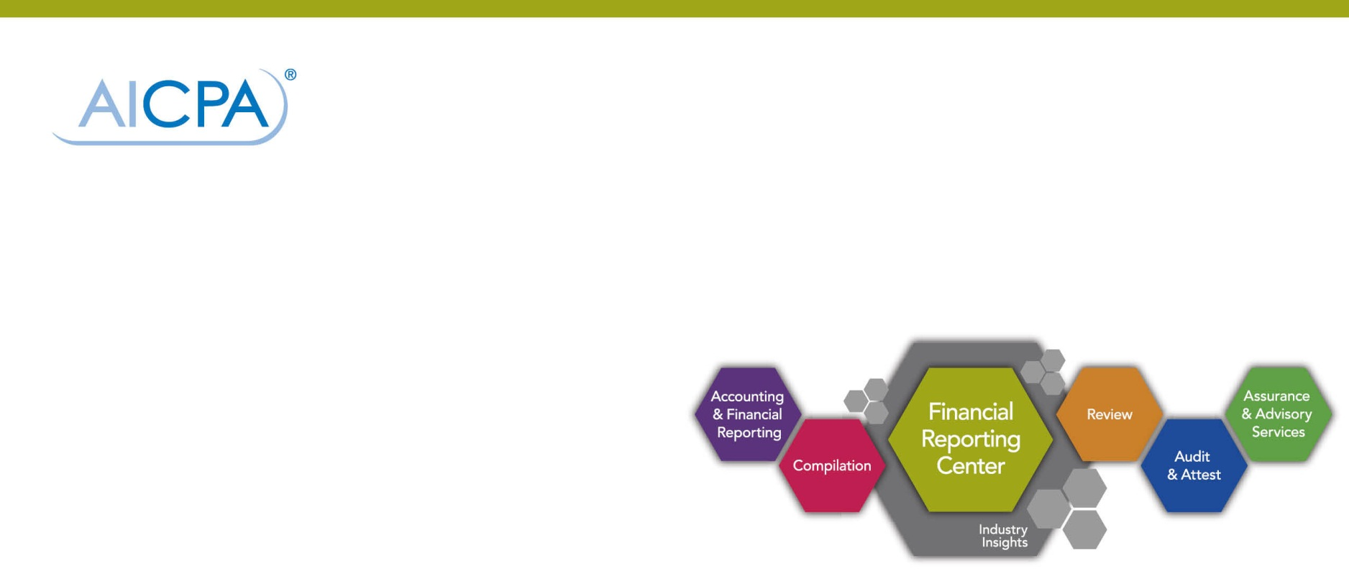

[THE NAME OF YOUR PRACTICE] understands that client applications for loans, health and life insurance coverage, government subsidy programs and even child adoption are predicated on verifying certain critical information. To gain some assurances that the information you provide is accurate, lenders, providers, regulators and various other government and nongovernment agencies will often request third-party verification letters from our firm. These letters might ask our firm to verify certain information that you have previously provided or that you are simultaneously providing. These verification letters are typically asked to be signed by us before they commit to providing a loan, a government subsidy or health insurance, to name a few examples. When these requests to you are made, we encourage you to seek our assistance.
Confidential Information and Matters of Solvency
[THE NAME OF YOUR PRACTICE] is eager to address third-party requests, but there are two types, which come with important caveats: those requiring we provide confidential client information and those related to matters of solvency.
If we receive a request from a lender or another third-party seeking verification of your information, you should understand we cannot provide any confidential client information without your signed, written consent. Likewise, obtaining our clients’ consent to share tax return information creates an added complication because using a standard client consent form is not sufficient. In fact, it’s a crime. Internal Revenue Code Section 7216 dictates that CPAs use a specific format to obtain consent to disclose client tax return information to a third party. Please be aware that [THE NAME OF YOUR PRACTICE] follows the Code when asked to provide copies of tax information, tax returns or other information used in the preparation of a client’s tax return.
Additionally, CPAs are precluded from responding to a requestor seeking any assurance on matters relating to solvency—or the ability for an individual or business to service its debt and meet its other long-term obligations. Matters relating to solvency are subject to legal interpretation under the Federal Bankruptcy Code and various state fraudulent conveyance and transfer statutes. Because these matters are not clearly defined in an accounting sense and are subject to varying interpretations, CPAs don’t have suitable criteria to evaluate a subject matter or make an assertion. Lenders are often concerned with legal issues on matters relating to solvency; however, CPAs are generally unable to evaluate or provide assurance on these matters of legal interpretation. The attestation standards preclude CPA practitioners from giving any form of assurance on matters relating to solvency.
However, [THE NAME OF YOUR PRACTICE] can provide a number of other types of responses or activities that address the concerns outlined in a request.
Understanding Other Types of Requests
A lender or entity may request verification of:
- Self-employment status
- Income
- Number of employees
- Business ownership
- Business profitability
- Business sustainability
- Real estate purchase impact on business
- Business loan impact
For these kinds of requests, there are usually several ways [THE NAME OF YOUR PRACTICE] can respond.
Determining the Proper Response
We can provide a response that states factual information or we might need to provide a more formal report, assuming the CPA has performed sufficient procedures and has a basis for the report. [THE NAME OF YOUR PRACTICE] may respond verbally or via email, form letter or other written channels.
Depending on the request, we may need to provide additional services, such as performing:
- An audit, review or compilation of financial statements;
- An examination, review or compilation of pro forma financial information;
- An examination or compilation of prospective financial information; or
- Agreed-upon procedures and reporting, as long as the agreed-upon procedures do not provide any assurance on matters related to solvency.
For example, if a loan you’re seeking is contingent on a request for self-employment verification, [THE NAME OF YOUR PRACTICE] may respond by performing an engagement to gather and provide the requested information for you or, if more assurance is needed, an examination or review engagement. The amount of assurance required by the requestor will dictate the associated compliance costs.
If your lender or other third-party requestor makes an inquiry and/or you’re not clear on the type of information they are requesting, please contact [THE NAME OF YOUR PRACTICE]/[CONTACT HYPERLINK OR PHONE NUMBER] and one of our CPAs will help you determine the best response or course of action to take.
DISCLAIMER: This publication has not been approved, disapproved or otherwise acted upon by any senior committees of, and does not represent an official position of, the American Institute of Certified Public Accountants. It is distributed with the understanding that the contributing authors and editors, and the publisher, are not rendering legal, accounting, or other professional services in this publication. If legal advice or other expert assistance is required, the services of a competent professional should be sought.
Copyright © 2014 by American Institute of Certified Public Accountants, Inc. New York, NY 10036-8775. All rights reserved. For information about the procedure for requesting permission to make copies of any part of this work, please email copyright@aicpa.org with your request. Otherwise, requests should be written and mailed to the Permissions Department, AICPA, 220 Leigh Farm Road, Durham, NC 27707-8110.

